Asbury revival brings ‘beautiful disruption’ and multi-generational community to post-COVID world

https://www.foxnews.com/media/asbury-revival-beautiful-disruption-multi-generational-community-christian-covid

Asbury University students say the revival is not ending. In fact, they say it is just beginning

By Nikolas Lanum | Fox News

Evangelist wants to keep spirits of Asbury revival going
Evangelist Nick Hall discusses how is wanting to keep the energy around the Asbury revival going on ‘Fox News @ Night.’
The small town of Wilmore, Kentucky has found a new sense of community following the Christian revival at Asbury University, where students say God is using them to bring together people across various cultures, genders, races and generations.

Even after weeks of travelers from across the world visiting Asbury, the final days of the revival brought new worshipers eager to open their arms to Christ. A couple from Japan holding makeshift signs waved at passing cars and blessed early-morning joggers. A group of missionaries from Canada strummed guitars and sang outside of Hughes Auditorium. A Dutch Christian group fed their children snacks while flipping through the pages of a Bible.
"Just different languages all at the same time praising God—like that's a taste of heaven," Asbury senior student Alexandra Presta told Fox News Digital. "That was just a glimpse into what heaven's going to be like."
For many students on the Kentucky campus, the revival was a flurry of new faces. With around 2,000 students, Asbury's community went from a small town to a small city within days. According to students and faculty, the revival brought over 50,000 visitors, including students from over 200 schools.
ASBURY UNIVERSITY STUDENT TELLS EMOTIONAL STORY ABOUT REGAINING CHRISTIAN FAITH AMID REVIVAL: ‘I RESENTED GOD’
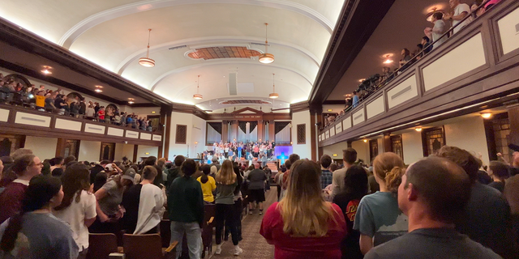
Students and young adults sing and pray at Asbury University on the Collegiate Day of Prayer. (Nikolas Lanum/Fox News)
During the revival, one of those faces found Presta in her time of need. The day had already been hard for her. She was processing a lot. Walking through the crowd, Presta felt a tap on her shoulder. She spun around to find a younger girl staring back at her.
"I just wanted to say that you stick out to me, and I think the Lord's pressing on my heart to tell you that you stick out to him too," she told Presta.
The girl began speaking affirmations. She had no idea who she was affirming of her spiritual gifts, but people, with seemingly no common ground besides their love of God, had a way of finding each other at Asbury.
"It just felt like God really saw me," Presta said.
Mark Whitworth, the Vice President for Intercollegiate Athletics and University Communications at Asbury, said the prayer services have led to an overwhelming response from students and visitors, including a yearning to return to their homes, communities, churches, and workplaces to share what God did for them.
Some suggested the revival had the most substantial impact on young adults, a generation desperately trying to find purpose, friendship and a life that seems even half as fulfilling as the facades found on social media.
"While they have access to all kinds of information globally, they also feel very isolated and then when you put the layer of COVID and lockdowns and things like that on top of their experience, even educationally and socially over the last several years—there are a lot of students in Gen Z that are really feeling alone," Whitworth said. "The Christian life is not meant to be done in isolation. It's supposed to be done in community."
Like many of his classmates, Khalil Akiky, a graduate student at Asbury University, hypothesized that the revival's success was because of the idea of "radical humility."
"No matter your age, what you look like, your title, all these things, when you're in the presence of the Lord like you are when you walk into Hughes, everyone is at the same level ground at the cross. So, we're all the same under Christ," Akiki said when asked to describe the concept.
ASBURY REVIVAL: PROFESSOR CALLS FOR END TO ‘PUBLIC PHASE’ AS SCHOOL SCRAMBLES TO ADDRESS OVERCROWDING
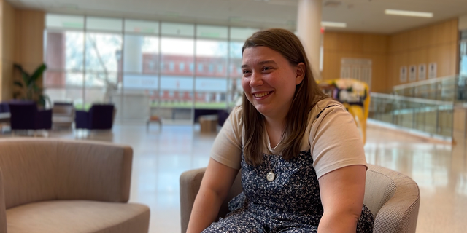
Asbury student Alexandra Petra works as the executive editor of the school newspaper and spoke with many interesting voices about the revival. (Nikolas Lanum/Fox News Digital)
In his opinion, the true spiritual movement is people's ability to become humble in the presence of Jesus. Everyone is broken and everyone is messed up, but everyone can begin to heal if they let Christ into their hearts and minds, he suggested.
"You see these 80-year-olds on their knees at the altar and then you have 40-year old's praying over them. And then you have 20-year-olds at the altar with 80-year-olds praying for them. You have high school dropouts praying over doctors and vice versa," Akiky said. "It's just so counter-cultural to what our world tells us and everything our world tells us about the hierarchy of classes."
Akiky noted that the revival is also different than most spiritual events. It is the young people of the world coming to know Jesus through Jesus, not necessarily through the church, not through religion, not through what many parents have taught their children. They are coming to know the true person of Jesus and God and his goodness.
"Everything the world will tell you to do as a college student has been just the opposite here. Here we're all laying our burden and our sins down with each other. We're all going to the cross together. There's no individualism here. It's all collectivism," he said.
The idea of collectivism cropped up repeatedly through discussions with students, who often described their relationships with the school under God as a singular force or body.
Jena Pelletier, a strategic communications student worker and senior at Asbury, said the revival was a reminder that students hold a collective power on the campus and the idea that, as Christians, you can be used at any stage in life for a bigger purpose.
She described the revival as a "cross-cultural, intergenerational experience," carried by students but paved by those who came before.
Pelletier recalled one of her early experiences at the revival, questioning whether everyone would engage with the typically contemporary Christian songs that got played inside Hughes. But she was amazed watching parents, grandparents and kids, whether they knew the songs or not, forced themselves to learn the lyrics and engage. There was no division during the time of worship.
"While it did start with the students and in many ways is kind of ending with the students, that whole in-between space is a reminder that the revival wasn't just for the students. It was for the world. It was for, in my opinion, all the generations," she said.
'ASBURY REVIVAL' MARATHON WORSHIP ENTERS 10TH DAY, SIMILAR SERVICES GROW ON OTHER COLLEGE CAMPUSES
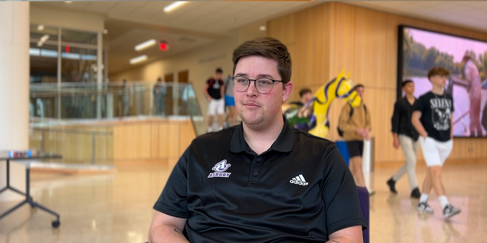
Asbury graduate student Khalil Akiky said the revival is just beginning and urged worshippers to help spread God's love. (Nikolas Lanum/Fox News Digital)
As a senior, Pelletier found herself looking back and wondering what it all meant. What did the last 14 days mean? The answer may not be easy, but Pelletier prayed for herself and everyone who came to encounter God on campus. She hoped something inside Hughes Auditorium would trickle out into the daily lives of all people.
"It's really easy to come and worship and pray with thousands of other people who are other Christians. You have that commonality. But I think the real practice and test is actually living that out," she said.
Working as a bridge between faculty and students, Pelletier said the revival opened the door for students to see professors as not only people but people who cared about them and their spiritual well-being.
A quick glance around campus coffee shops, communal areas and courtyards saw faculty and students cohabiting regularly. During Thursday's Collegiate Day of Prayer, one professor picked up a ping pong paddle and played with a student, asking him about an upcoming Biology exam. Another checked in with a student who recently had a tough softball game.
A jug sitting on a table in the corner of the student center contained the university president's favorite soft drink. Students said Dr. Kevin Brown himself would often come to have a cup and converse with nearby students.
"While they are our professors and teachers, I think it's created a lot more personal relationship with them. Even going to them and saying, 'Hey can you pray with me," Pelletier said.
Throughout the revival, faculty even created spaces for students to process what they had been experiencing inside Hughes auditorium.
Asbury senior Jena Pelletier said it was important to highlight how the revival brought people together across generations. (Nikolas Lanum/Fox News Digital)
"It was just a reminder that we're always going through this together, not just the students, not just Asbury faculty, but the world," Presta said. "If there was any bitterness between faculty and staff, I personally don't feel that anymore, and I feel like we all are now closer together. We're a team, we're the Asbury community and we all agreed it's not about us, but we're all going to unite because it's about Jesus and we want to represent him well."
Whitworth, in part, credited the deep community bonds to the university's urge to instill a biblical worldview and awareness of God's deep and abiding love into the student body.
CARDINAL DOLAN EXPRESSES HOPE FOR RELIGIOUS REVIVAL ON ASH WEDNESDAY AFTER ASBURY UNIVERSITY DAYSLONG SERVICE
He said that the outpouring has created a warmth, even in his own heart and relationships with students, faculty, and staff, as well as a willingness and openness to engage with others on a deeper level.
"We are all seeking God. It's not about our own agendas," Whitworth said.
Whitworth also applauded students and faculty for the countless hours it took to welcome people worldwide into their community in Wilmore. The revival coincided with midterms on the academic calendar and discussions in the halls of Asbury frequently oscillated between chats about the revival and questions for upcoming exams.
While students did the hard work for mid-semester, they also put in the "heart work," as Whitworth called it.
"I'm so encouraged. I'm so blessed, honestly that our students were the ones that were really so receptive in the early hours," he said. "They were in tune, and they were hungry to go deeper with God."
One faculty member described the revival as a "beautiful disruption" for the campus.
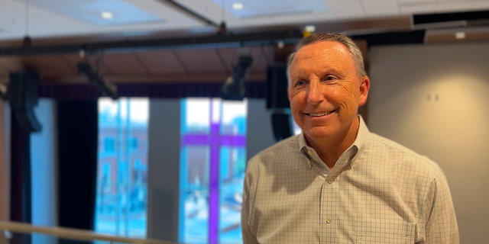
Mark Whitworth, the Vice President for Intercollegiate Athletics and University Communications at Asbury, expressed pride in his students for how they helped shape the revival. (Nikolas Lanum/Fox News Digital)
But not everything came easy for students and faculty as the town fell under the international spotlight.
Eswin Monroy wears many hats. He is a coordinator for the campus shuttles and works at the student center, among other things. Like many of the students at Asbury, he appeared humble, quick to highlight the accomplishments of others and slow to point out his own personal achievements.
When asked what title he would like to have for the interview, he simply said, "a member of Asbury."
"We have been crying out for a revival here at Asbury for the past 10-20 years. And to be part of the generation that brought it into being is just remarkable. It's something that no one ever expected, but when the moment came, people did not initially feel ready," Monroy said.
PASTORS BATTLE SKYROCKETING BURNOUT AMID POLITICS, PANDEMIC: ‘WEARING ON THE SOUL’
Students and faculty questioned if there were enough people to follow up with those praying at the altar, and whether there was enough food and diverse worship teams to guide the crowd through long hours.
Members of The Board of Trustees and faculty worked as ushers in the evening to ensure everyone who needed a seat could get one inside Hughes Auditorium.
But amidst all the noise, leadership never shut students out. They included them in everything. Students say they have never been closer with any of the administration. Faculty frequently check in on students, but throughout the long hours of the revival and the critical tasks at hand, students have also begun checking in on their teachers.
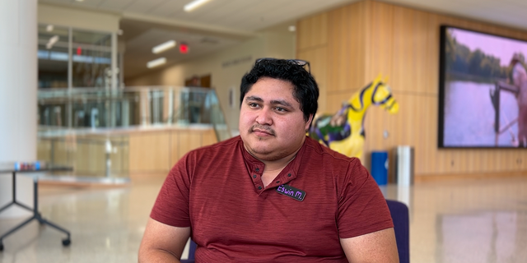
Asbury senior Eswin Monroy expressed hope for the future of Christian revival as he ruminated on his final months at the university (Nikolas Lanum/Fox News Digital)
"I know personally I never checked in on my professors a ton, besides the kind of 'Hey, how you doing.' To see that kind of change for the better is amazing," Presta said. "At Asbury, we do throw the word community around a lot, but I think as a senior, I'm finally starting to understand what it actually looks like."
For Monroy and the rest of the students, the revival was a learning experience. It was uncharted territory. It may sound contradictory, but when Monroy was asked how he and others handled the massive influx of worshipers, he said, "If you don't take a leap of faith, then you will never know what to do."
"The community is like a net. When you need help, everyone comes in and brings that reinforcement," he added.
But none of this was planned. On Monday, prayer services were closed to the public and the remaining days featured prayer services mainly for ages 15-25. Some accused the school of shutting down a historical revival. Others posited theories that the school had reasons for limiting the prayer services.
THIS ASH WEDNESDAY, DISCOVER THAT LENT ISN'T WHAT YOU THINK IT IS
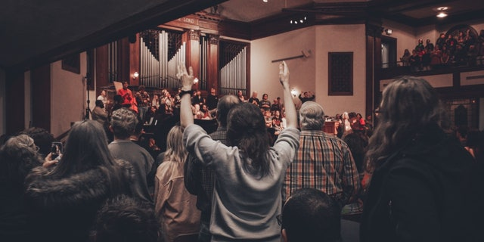
Students raise their hands during a service in the chapel at Asbury University, which has seen participants flocking in nationwide to witness its revival. (Asbury University )
Many of the students that spoke with Fox News Digital echoed Brown, who, fielding questions about the "end" of the Christian revival, noted that "you really cannot stop something that you didn't start."
"My hope is that everyone knows that the same spirit moving in Hughes is the same spirit that is moving all over the world," Monroy said. "Hughes became the epicenter of it. But God lives in our bodies."
Students across the board urged worshipers to spread their message and help continue their work outside the confines of Asbury. They vehemently denied that the end of 24/7 prayer was the end of the Christian revolution taking place in their hearts and the hearts of people worldwide.
"We don't want to stop this. Why would we want to stop something so good and so pure?" Akiki said. "What God wants us to do now is take this, take what we've experienced and take everything that God has filed us with and to move and to go out with it."
CLICK HERE TO GET THE FOX NEWS APP
Students were hopeful. They never want the revival to end, they want it to spread. And it is spreading. The revival had already caused ripple effects, not just throughout the nation but throughout the world. Whispers of revivals have cropped up in local news stories across the globe. In some areas, the whispers have turned into song and prayer.
"We all have a spigot to the water of life in us," Akiki said. "We just have to learn to open it and pour it out wherever we go,"

